

February
Newsletter

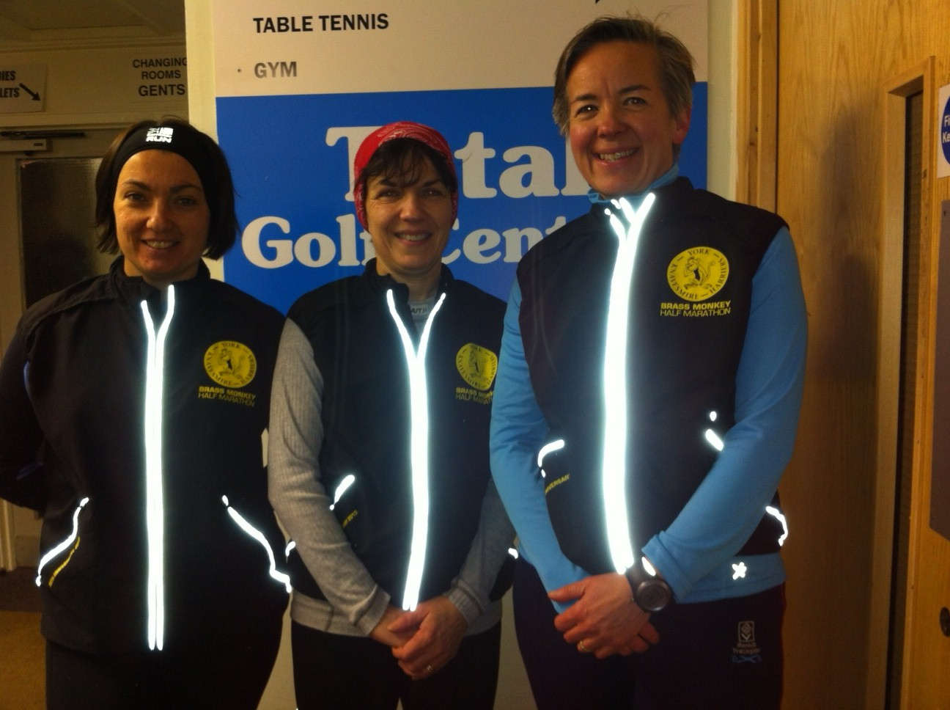

We battled the winds and caned the Brass Monkey!

Verity, Debbie, Ann, Antonia, Lynda and Yendis

Annual General Meeting – 3oth March

This will take place at Il Mundo’s, on Newland Avenue at 7.30 pm.
The AGM is a celebration of a year of running with the Club and includes a presentation to the winners of the WHL 10K Series, Improver of the Year and Member of the Year.

Committee members are also voted in. It’s also an opportunity to see if you can recognise your running mates when they are not in running kit!

Check your emails for more information.

WEST HULL LADIES RRC
COMMITTEE MEETING 6/2/2012

Apologises:- Geri Wright, Rebecca King, Victoria Voase
Attendees:- Amanda Dean, Jo Townsend, Ann Holmes, Katy Snow and Louise Ede

- London 10k - Verity will be asked to add this to the race page.

- Run England website - AD confirmed that she completed a Leadership in Running Fitness Course and will arrange to send details to LE. LE will then contact England Athletics about the Club being named on the England Athletics website.

- AGM - the dates identified were 23/3/12 or 30/3/12 depending on the availability of the other committee members. Venue will be Il Mundo on Newland Avenue.

- Trophies for AGM - LE will organise trophies for Member of the Year, Improver of the Year and winner of 10k series. LE to liaise with VV about where trophies purchased in previous years. LE to circulate e-mail to obtain nominations for Member of the Year. The deadline for identifying the winners is end of February 2012.

- Vouchers - LE to organise

- Committee Member Roles - this will be circulated and the ladies will be encouraged to become involved with the Club.

- Raffle - there will be one raffle ticket per person sold on the night. Everyone will be asked to bring a present for the raffle.

- Hull Marathon Station - KS will place order for the banner. KS will chase organisers of marathon to see if we can move the banner to Queens Gardens once all the runners have passed our station at 3 miles.

- Hull Marathon Teams - these have not yet been confirmed. The teams will need to be confirmed by the beginning of March 2012.

- Champagne League - Verity, Sandra and AD would wish to take a place. It starts on 27/3/12. An e-mail will be circulated to the ladies. There are 8 places available.

- Library books - these will be left upstairs (near the toilets at the end of the corridor) at Hull Sports Centre for people to borrow.

Next Committee Meeting - 5th March 2012

Training Officer Report and General Running Tips

Barring snow stopping play ... 2012 has been really positive. Everyone is making progress with new runners coming on rapidly and the marathon running ladies are getting stronger and stronger. We’ve had good turn outs for all the training sessions and the support for each other is fantastic. Keep enjoying your running and you will just keep getting better.

Running tips from your training officers:

- Enjoy your running:
Hopefully with such a lot of friendly, supportive and positive runners in the club it’s not too hard to get out and run regularly.

- Run efficiently to make it easier:
No over striding! Learn to land on the ball of your foot, not your heel, which causes you to brake at every step. Take note of your posture, remember your legs do the work and hips upwards should be upright and your shoulders relaxed with a gentle arm movement. Learn to breathe down into your stomach.

- Avoid injury
- By learning to run well (no. 2);
- By cross training, in particular doing exercises to strengthen your core muscles
- By stretching. Work out what are your tight bits and stretch them regularly
- By looking after yourself: sleep well, eat well, stay healthy. If you are tired, under the weather your body is too and you are more prone to injury at this point so learn when it is prudent to go easy.

- Increase your weekly mileage.
It’s really easy to get hooked on how well you are doing because you have run further in one go than ever before at one go but your weekly mileage is more important and all our marathon runners can tell you just how true this is. You might feel really pleased that you have run twice in a week doing a 4M and a 7M but running 5M, three times a week is better. The weekly mileage is your foundation and building this up steadily will strengthen joints and muscles without risking injury.

- Run further

It is very positive to run further than before and as long as you do this gradually and alongside building up your weekly mileage you will ‘take it in your stride’.
Amanda’s formula:
Long run = daily average mileage x 3.

Weekly | Daily Avg | Long Run
14M | 2M | 6M
21M | 3M | 9M
28M | 4M | 12M
35M | 5M | 15M
42M | 6M | 18M
49M | 7M | 21M

- Speed train
Its fun and you get faster. Don’t miss the sessions.

Happy running,
Amanda & Jo

Over-Striding and How to Correct It
By Rick Morris

After worn out shoes and failure to warm up properly, over striding is the biggest threat to running performance, a factor which increases considerably among novices. It's very tempting to stride out too far as a way of either conserving energy by decreasing turnover or increasing your speed by covering more ground, but in both cases over striding will have the opposite effect.
There is no doubt that over striding is the most common running form flaw among distance runners. I have coached many hundreds of runners during my career and over 90% of my clients tended to over-stride when they came to me. Over-striding is caused by reaching out in front of your centre of gravity and landing on your heel.

Photo below, although beautiful, shows over-striding with the heel coming down first.


If your foot lands too far in front of your hips, it will put unnecessary strain on your knees and hips, as the impact of landing will not be absorbed in the vertical line from the feet through the ankles and knees to the hips. The knees will bear most of this unabsorbed shock as they are the pivotal point between the planted lower leg and the still movement upper leg, this can also cause shin splints and the iliotibial band will also suffer because the jointing involved will create all sorts of friction around your hips. Because over striding pushes you to land on your heels, they will also take a bashing, as will your Achilles tendon.

Your performance will be affected in terms of both speed and endurance. Because of the jarring from landing on your heels, and your centre of gravity having to catch up with your lower leg, you are effectively putting the brakes on. The jolt stops your stride cycle being smooth enough to gain maximum momentum, and in the time it takes for to roll from heel to ball, the elastic recoil energy will be lost and you will be expending energy for a much greater proportion of each stride.

To avoid or correct over-striding, concentrate on landing on the ball of your foot with your foot directly under your centre of gravity. This will allow you to maintain most of your forward momentum. You should feel as if you are gliding smoothly along the ground with little impact or vertical motion.
Shorten your stride if you have to - the average runner should be taken between 85 and 95 strides a minute; much less than that suggests you over striding -- then, if you want to cover more ground, increase your time in the air without overstretching your leading leg.

A Message from Kirstie the Physio

Remedial massage - update from Kirstie
I wanted to write a short message to the West Hull Ladies Running club, to update you all on recent developments in my massage practice. After the birth of my daughter, I developed severe tendonitis in my wrists and thumbs, which is proving to be extremely painful. I have therefore decided to take an extended period of leave from my practice to give my wrists and thumbs a chance to rest. In my absence, Maxine McFarland will be treating my patients at Wadsworth Osteopaths, to try to maintain my practice whilst I am away. She is both a qualified osteopath and remedial massage therapist and will, I know, be delighted to treat members of the West Hull Ladies. You can book an appointment with her by calling 01482 875004.
I also wanted to say a great big thank you to all those ladies who have supported my practice in the past. I hope I may be able to return to massage in the future and, if so, I look forward to seeing you all again.

With best wishes and many thanks,

Kirstie.

Brass Monkey

Lynda

Hello Ladies

I sign up to do the Brass Monkeys each year & never feel up to it, as it is so soon after Christmas & end up giving my number away...Well this year it was sods law that I tried to enter the race & within hours it was full!!, fortunately there was one of you ladies not able to do it (thank you Sarah) & I took the number....Myself Antonia, a Springhead runner & a couple of old members of WHL ladies all took a road trip to York, all of us nervous about the race...I had burnt out the week prior, so wasn't expecting a great performance, so just kept saying to myself it's a jolly with the girls & treat it like a training run....after muttering how cold it was, peeing behind a car & dropping my gloves in a puddle, we jogged back to the car to get togged up for the start of the race...
We all started quite far back, so we set off nice & steady when I heard this almighty shout "Go on Lynda!" from my COH Ladies Captain Cheryl Lyons, which really spurred me on put me into race mode & I was off!...I got blown all over by the wind but managed to push on, saw Debbie at the start & ran with fellow Barracuda Jacqui a few miles on, then had a gel at 8 which helped me to push till the end, my hips was hurting a bit at the end, but when I realised I was running over the finish at 1hr 50 I was really elated & even more so when I learnt my chip time was even better, saw Ann at the end, she was really pleased with herself & looked glowing....I think the last time I did a half marathon was a fair few years back & it was a good 10 mins over 2hrs! & it was such hard work, this time I ran it with ease & enjoyed it....so was really chuffed!!..I really recommend this course as it is in the shape of a lollipop & nice & flat.
Lynda Hields

Ann

The week before Sandra commented to me that she wasn’t doing this race because she couldn’t resist racing it instead of using it as a training run, and I wondered what I should do. I’d been totally wiped out after the Great North in September, running in 2.07.54, but I couldn’t help wonder whether a sub-2 was possible.

I spend some time number crunching beforehand and worked out that if my first two miles were 9.30, and if I kept to 9.15 after that, then I’d be just under the 2 hours. I figured it was worth a try, but if I didn’t tell anyone, then I’d nothing to lose if it didn’t work out.

Thanks to Verity for driving over – we talked running pretty much all the way there and back. This race was really good, because HQ was a big, warm complex with toilets all over the place, well organised baggage, and sofas! We met up with Debbie and Annette and family, and stayed layered up right until 10 minutes before the start, then dropped off our bags, and out into the wind.

The wind!! This made the run exhilarating – it really blew me sideways at times. I’d taken the first couple of miles at about 9.22 ish, but then with the cross wind tried to speed up a little to compensate for when the wind was head on later, so up to 9.15, and then up a bit more, just in case.

Fewer onlookers than the Great North of course, but very enthusiastic marshals made up for this. The course was flat and rather dull, but the encouragement from marshals, particularly from the half way point was a real boost, and I upped my speed again. I was feeling good – must’ve been my new trainers, and managed to keep at 8.45 for the last half of the race.

I chased ‘man in red T shirt and Skins’ for the first 4 miles, then left him to take on ‘little lass in pink jacket’. We were neck and neck for about 6 miles, until I finally left her towards the end. Funny – she found me and thanked me for keeping her pace up at the end, and yet she’d done exactly that for me! Turns out she wasn’t a ‘lass’ at all – funny how you make assumptions about people you see only from behind or out of the corner of your eye!!

So, a last big push over the two bridges – I was tired but there’s no point in slowing down now and yes, I managed a sprint finish to make it 1.58.0 – well pleased!

I bought my photo to celebrate -

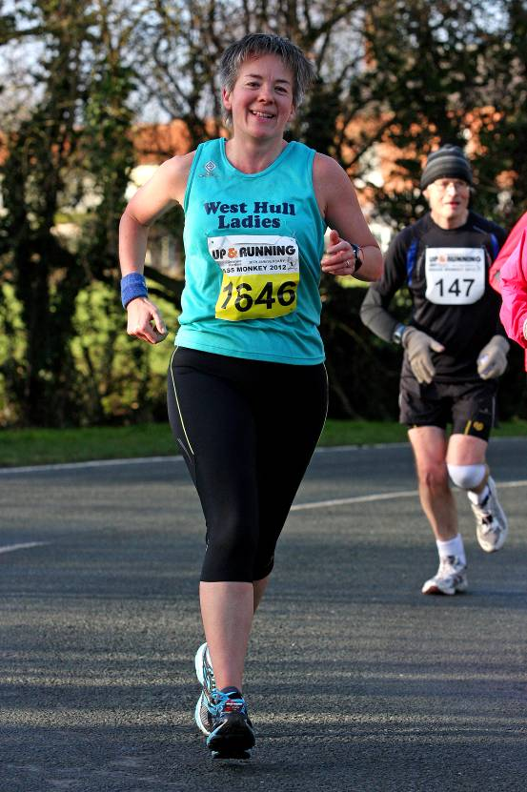

I’d recommend this to anyone who wants a good run and isn’t too bothered about scenic delights along the way, but you need to be quick off the mark to get in!

Debbie

Brass Monkey's was my first ever half marathon 3 years ago so I had fond memories of the event and was pleased to get a much coveted place this year. However it was with trepidation that I joined the runners on the start line on Sunday, my fitness levels have been varied of late and my training? I actually spent saturday night counting the miles that I had run over the previous few weeks saying to myself you'll be fine be positive. I was so glad so see Ann, Verity, Yendis, and Annette at the race course and it was a welcome distraction to sit and chat on a comfy sofa.
I set off at a comfortable pace and felt surprisingly well, so that was a great relief. The sun was shining, however there was a ferocious side wind and I tried to get alongside someone to prevent being blown sidewards, this worked for a while. The runners were chatty and friendly and the marshalls were very encouraging so all good so far. In fact I was very comfortable for 9 miles which really gave me a confidence boost. I started to struggle at mile 11 and 12 the wind was head on at that point, I had my eye on Lisa from Pocklington and got past her then she got past me and I found something extra for the last mile and got past her again, she very kindly said 'well done'. I have to say I have never been so glad to get over the line (in one piece) and was so pleased to see it was under 2 hours.

One day ...

Susan

Having left my comfort zone of 10k since joining the club and buddying Geri for her marathon training I’ve upped the ante to aiming for a half marathon in 2012. I’m aiming at an event late Summer/early Autumn. I’m one of those people though that when I have a goal I like to break it up to keep the interest and enthusiasm there until the date of the event, so last week I entered for the Hornsea Third Marathon on 1st April. I've even taken Annual Leave that weekend in order to run the third marathon!!!!
Currently have a chest cold at mo so having to rest on the running :( Hope to be back with WHL and Geri's Marathon Buddy real soon!

Ladies’ Running Tips ...

Verity

Marathon nutrition – post long-run recovery, Pick style – one bottle of Lucozade and a couple of bags of crisps ... !

Ann

ASSOS Chamois Crème – I bought some of this when I cycled the Transpennine Trail for the body area that’s most prone to saddle sore, if you get my drift. It worked a treat, and now I use it on my toes on my long runs and it stops me getting blisters. It isn’t cheap, but one pot lasts forever, and it makes your feet feel lovely and cool.



Keep the tips coming in, ladies – however simple, they are sure to be of interest ...
Racing and Running Events

Date | Event | Distance | Fee | Entry / website
February
26th 11.00 | Snake Lane | 10 ml | Full | Full  www.pocklingtonrunners.com
March
18th 10.00 | East Hull 20 | 20 ml | £16 | www.easthullharriers.com
April
1st 11.00 | Hornsea Third | 1/3 Marathon | £10 | http://www.hornseathirdmarathon.org.uk/
6th 10.00 | EHH Winter League, Hill Run, Elloughton | 7 ml | Free | www.easthullharriers.com  Turn up on the day
8th 8.00 | Hull Marathon | Marathon | £38 with 10% discount, use WHL01 code | www.hullmarathon.com
8th 10.00 | Helmsley Multi Terrain Challenge | 10k | £10 | www.helmsleysports.org
18th 6.30 | EHH Winter League Riverbank Run: Ennerdale | 6 ml (staggered start) | Free | www.easthullharriers.com  Turn up on the day
28th 8.00 | The Woldsman | 50 ml | £15 | http://www.ldwa.org.uk/EastYorkshire/E/8580/the-woldsman.html
May
6th 9.00 | Nth Lincs Half | Half marathon | £22 | www.northlincshalf.com
13th 11.15 | Beverley 10k | 10k | £12 | www.beverleyac.com
June
3rd 9.00 | Jane Tomlinson Hull | 10k | £24 | www.runforall.com
July
8th 9.00 | Jane Tomlinson Leeds | 10k | £24 | www.runforall.com
8th 9.35 | British London 10k | 10k | £50 (guaranteed) | Ballot entry for £32.50  www.thebritish10klondon.co.uk/
8th 2.00 | Kilburn Feast | 7ml | £10 | www.realbuzzbritain.com
August
5th 9.00 | Jane Tomlinson York | 10k | £24 | www.runforall.com
25th 8.00 | Smugglers Trod | 17 or 25 ml | £8 | http://www.ldwa.org.uk/YorkshireCoast/W/1416/2012-smugglers-trod-entry-form.html

** Dates/times are subject to change **
Keep checking the website for new races and updates: www.westhullladies.org.uk/races.htm Verity, Racing Officer

“The most impressive thing about marathon runners is how they don’t check their phone for over 3 hours.”

If two collars had a race, how would it end? (answer below)
You know you’re a runner when -
- You can convert kilometers to miles or vice versa. Sometimes, you can even do that while running.
- You know exactly how many miles there are in a marathon.
- You have had at least one toe nail become purple or black, and it wasn’t nail polish.
- You can discuss bodily fluids and gastrointestinal issues without flinching. Thinking “ewwww” never crosses your mind. Usually, you are thinking “I hope that doesn’t happen to me” or “Ugh. I hate when that happens.”
- Getting up at 6 a.m. on a Saturday morning to run for two to three hours doesn’t sound like an outlandish, cruel punishment. Instead, it sounds like the perfect way to start your weekend.

In a tie.
(If you have a better running joke than this (which wouldn’t be hard)
then email in!)

NOTE: Club Vests must be worn at any races you enter
under the West Hull Ladies running club name.

Clubwear
PRICES:
Vest | £15.00 | All items are ordered on request and must  be paid for at time of ordering. To place an  order please get in touch via West  Hull Ladies e-mail and mark your emails  for the attention of Geri.
T- shirt | £16.50
Hoodie | £14.00
Jacket | £32

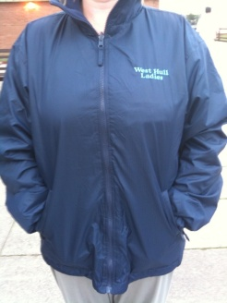

New Club Jacket available in three sizes: small, extra small, and junior (large fitting). If you would like to purchase one please send a cheque for £32 to Victoria Voase, Treasurer, and state on the back of your cheque your name and that the cheque is for a jacket.

Becca

Running Library

You can borrow any of these books – they are upstairs near the toilets at the end of the corridor
Book List:
- The Runner's Diet (Runners World), Madelyn H. Fernstrom
- Paula My Story So Far, Paula Radcliffe
- The Runner's Handbook, Bob Glover
- The Competitive Runner's Handbook, Bob Glover & Shelly Lynn Glover
- Marathon Running For Mortals, John Bingham

- Lore of Running,

Running Magazines: These are available to borrow by emailing the club website.
Mark your email for the attention of Becca.

